SUNDAY 18th May 2014
LUNCH DRIVE TO BUNDANOON COUNTRY HOTEL
via TREE TOP WALK AT ROBERTSON
Another fabulous PCNSW Drive. Starting from Bunning’s Car Park Cross Road (Beech Rd Casula). This is a joint event with the Canberra Porsche Club who we are meeting for lunch at Bundanoon.

Meeting at 9am for a 9.30am getaway we proceed on the M5 Freeway South turning off at Wilton, heading to Wollongong via Mt Ousley and then along Southern Freeway to Illawarra Hwy and up Macquarie Pass to Robertson in the Southern Highlands
Here we will stop for about 1 hour and you will have the choice of either enjoying a pie and coffee at the famous Robertson Pie Shop or for the more adventurous a quick tour of the relatively new Illawarra Fly Tree Top Walk: www.illawarrafly.com where you can also enjoy a morning snack. For $25 for big kids and $10 for little kids you can have a climb and enjoy some spectacular views. However, we will only spend an hour there.
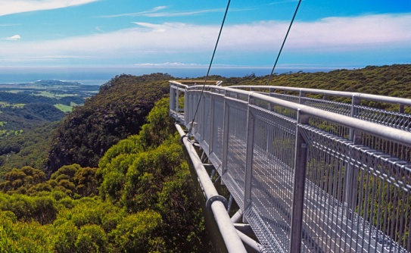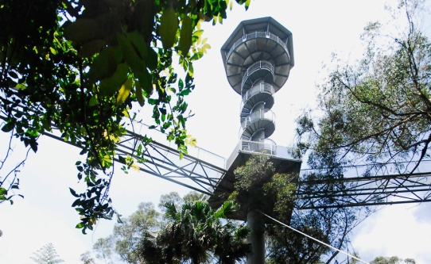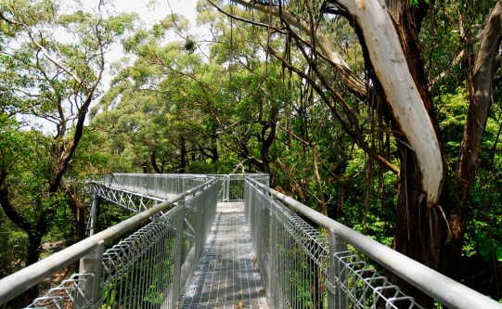
From here we proceed to Bundanoon via Illawarra Hwy, Moss Vale, Sutton Forest, Exeter, to the Bundanoon Country Hotel for a delicious lunch in a stunning historic country hotel.
Registration for this drive is $50 for per person. This will provide you with a 3 course abundant lunch of wholesome country pub food.
All other costs will be up to individuals on the day.
Come enjoy a fabulous and interesting drive in your Porsche. Book early as places are limited.

