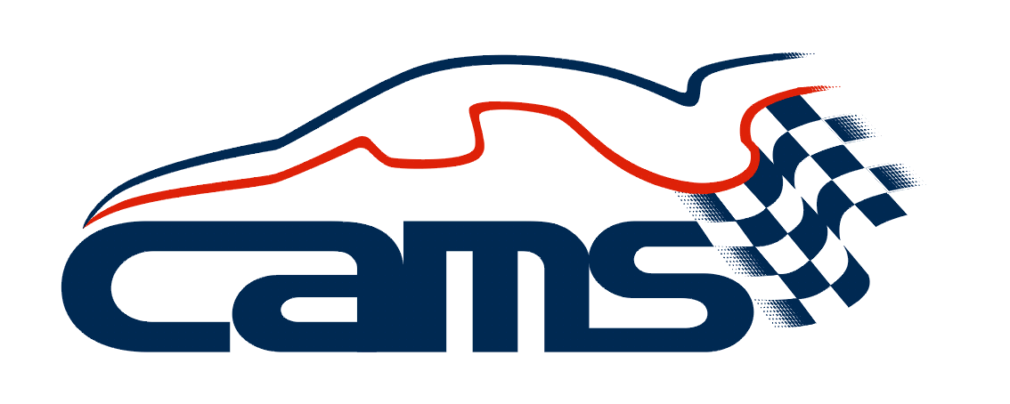
STANDARD SUPPLEMENTARY REGULATIONS
CLUB MOTORKHANA

PCNSW 2019 TONY MCKNIGHT MOTORKHANA CHAMPIONSHIP – Training Day
Sponsored by Buchannan Automotive, Balgowlah

- Authority: This Event is held under the FIA International Sporting Code (ISC), the CAMS National Competition Rules (NCR) the CAMS National Motorkhana Code, the NSW Motorkhana Addendum, these Supplementary Regulations, and any further regulations issued by the organising club. This Event will be conducted under and in accordance with CAMS OH&S and Risk Management Policies, which can be found on the CAMS website at www.cams.com.au.
- ORGANISING CLUB: Porsche Club NSW Inc. PERMIT NO:TBA
- NAME OF EVENT: PCNSW 2019 Tony McKnight Motorkhana Championship
Training Day
Sponsored by Buchanan Automotive
- DATE : 2nd February 2019
- VENUE / LOCATION: Eastern Ck, Skid Pan (Sydney Motorsport Park)
- TYPE OF SURFACE: Concrete, wet and dry
- TESTS TO BE CONDUCTED: As per motorkhana handbook
No. of tests: See item 31
- INVITED CLUBS (WHERE APPLICABLE):
- CLERK OF COURSE: Kim Woodward (tbc) PHONE: 0430 298 658
- FURTHER OFFICIALS: Not applicable
- ENTRIES
Entries will be accepted in order of receipt, and must be accompanied by the entry form and entry fee. Entries may only be submitted online using the online entry form and payment process on the club’s website: www.pcnsw.com.au under “Events”.
ENTRIES OPEN DATE: On publication of these regulations
ENTRIES CLOSE DATE: 31st January 2019
Entries will not be accepted after this date or on the day of the event.
- ENTRY FEE: $50.00 per half day
- MAXIMUM NUMBER OF COMPETITORS: 40 per half day session
- MAXIMUM ENTRIES PER VEHICLE: 2
- STARTING TIME: Scrutiny 8:30 am and 12:30pm
- DRIVER'S BRIEFING: TIME: 9:00 am and 1:00pm
VENUE: Officials’ building (near skid pan entry gate)
- SCRUTINY: TIME: 8:30 am and 12:30pm
VENUE: West side of skidpan (by the access road)
- SCRUTINY - SPECIAL RESTRICTIONS:
Approved helmets in accordance with Schedule D of the current CAMS Manual are to be worn in ALL specials. Fuel must be in accordance with Schedule G of the current CAMS Manual. All cars must be adequately muffled.
Documents required to be presented will include a CAMS licence, a Club Membership Card and, if issued, a CAMS Vehicle Log Book.
- CLASSES: Not Applicable for Training Day
- TROPHIES: Not Applicable for Training Day
- The CAMS permit will be displayed at the start of the event.
- The organisers may refuse any entry in accordance with NCR 83
- Entries will be accepted in order of receipt, subject to Item 11 and 12.
- Entries for drivers under 18 years of age must be counter signed / consented to by a parent / guardian.
- Personal Accident Insurance is provided by the purchase of a CAMS Competition Licence. For further details of CAMS Insurance provisions please refer to Appendix I of the Current CAMS Manual.
- A Level 2NS Licence or superior is required for each driver. One Day only Level 1 Licences will be available for issue on the day for people who wish to participate for the first time.
- Public Risk Insurance has been effected by the organisers.
- The organisers may cancel, alter, abandon or postpone the event in accordance with NCR 59,
- Not Used
- Use of prohibited Substances
During any event, consumption of alcoholic beverages in the paddock, pits or any other portion of the competition venue under the control of the officials is expressly forbidden until all practice or competition activity is concluded for each day. Any driver or crew member who is found to be affected by alcohol on the day of the event or practice therefore shall not be permitted to participate. Refer NCR 145A of the Current CAMS Manual. In addition, the persons concerned will be subject to the Articles of the Standard Operating Procedure for Alcohol Testing and CAMS Anti-Doping Policy. Competitors, crews or officials may be randomly tested for alcohol by a CAMS Accredited Testing Official (CATO) or other drugs at any time during the event(s).
The CAMS Anti-Doping Policy, as appears in the CAMS Manual of Motor Sport and as amended from time to time, is recognised as an integral component of the NCR and is duly authorised as such. In any areas where the National Competition Rules and the Anti-Doping Policy conflict, the Anti-Doping Policy will take precedence
- Passengers in Cars
At the discretion of the Clerk of the Course, passengers may be permitted to ride in cars with drivers nominated by the Clerk of the Course. These rides will be conducted in accordance with current CAMS Motor Sport Passenger Ride Activity policy.
- Special requirements
  - The day is run as a Training/Tuition programme for members to learn or improve their skills in Motorkhana
  - The day is split into morning and afternoon sessions with participants able to enter either session or both.
  - There will be 2 test layouts in each session with runs for each layout. Timing is optional.
  - Diagrams of the tests will be given out at Registration and published online
  - Course markers will consist of brightly coloured cones or witches hats
  - At the Clerk of the Course’s discretion, non-competitive tests may be run before and/or after the competition.
  - Drivers and spectators must keep well clear of the competition area at all times. Specifically, drivers must not pull forward into the start garage until called by the start marshal.
  - The starting signal will be a hand signal given by the timekeeper. Timing begins when the car leaves the start garage.

